# Introduction

This is the documentation of the RA2CE Python Package on the (currently closed) Deltares Github repository <https://github.com/Deltares/ra2ce>. This is a Deltares internal document and not to be shared with externals without approval from Margreet van Marle.

# Workflow

We recommend understanding the RA2CE workflow before making use of the toolkit for the first time. Follow Figure 2.1 from top to bottom to understand the high-level workflow. RA2CE is developed to be used in three ways:

* Create one or multiple networks
* Execute one or multiple analyses with an existing network
* Create a network and execute analyses

Two configuration files, also called initialization files, are

Figure 2.2 Figure 2.3

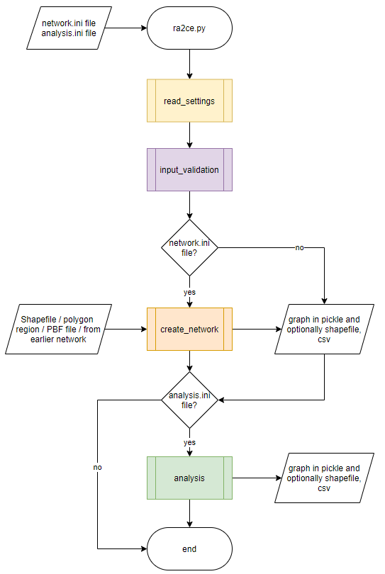

Figure 2.1 High-level RA2CE workflow. **Create network** and **analysis** are expanded in the next figures.

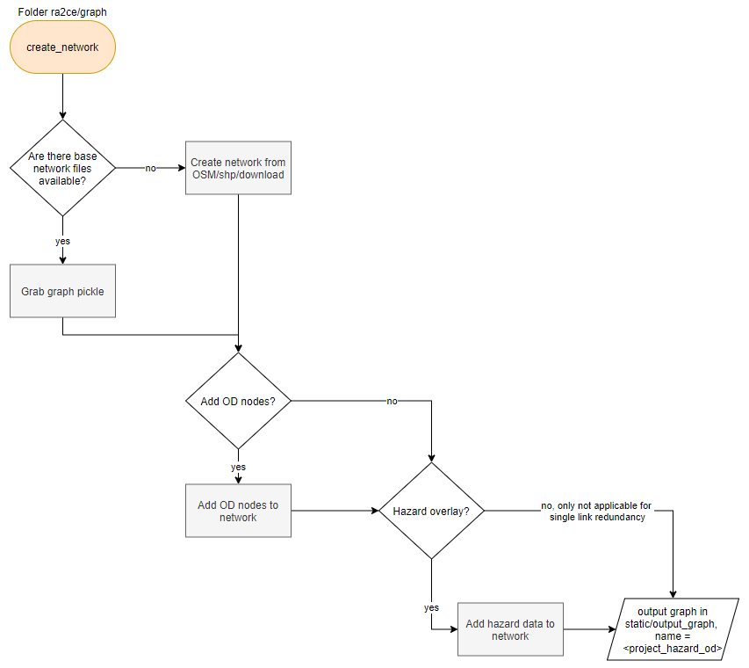

Figure 2.2 **Create network** workflow.

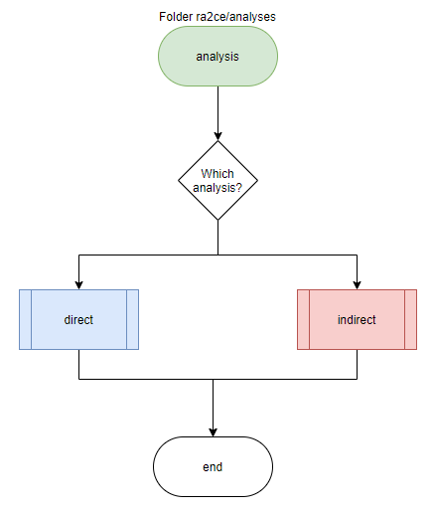

Figure 2.3 **Analysis** workflow.

# Initialization files (*.ini)

# Contact - RA2CE development team

Margreet van Marle | Product Owner

Frederique de Groen | Development Team Lead

Bramka Jafino | Developer

Martijn Kwant | Developer

Kees van Ginkel | Developer

